



**Supervisor:** *NGUYỄN HẠ VY*

**Semester:** *01*

**Batch No:** *T1.2208.A2*

**Group No:** *06*

|  |  |  |
| --- | --- | --- |
| **Order:** | **Full name** | **Roll No.** |
| *1.* | *HỒNG NGỌC NHI* | Student1409670 |
| *2.* | *PHÙNG THỊ THÙY LINH* | Student1408057 |
| *3.* | *NGUYỄN BẢO TRÂN* | Student1409669 |
| *4.* | *NGUYÊN TRUNG NGUYÊN* | Student1409156 |
| *5.* | *NGUYỄN ĐỨC TÚ* | Student1409130 |

***Month****: 10* ***Year****: 2022*



This is to certify that

**Ms. HỒNG NGỌC NHI Ms. PHÙNG THỊ THÙY LINH Ms. NGUYỄN BẢO TRÂN**

**Mr. NGUYÊN TRUNG NGUYÊN**

**Mr. NGUYỄN ĐỨC TÚ**

Have successfully Designed & Developed

# PRIME FITNESS

Submitted by:

**Ms. NGUYEN HA VY**

Date Of Issue:

Authorized Signature:

# Content

Content Acknowledge Synopsis

Review 1

Review 2

Review 3 ..

Task sheet ..

# Acknowledge

As we understand that the eProject is a step-by-step learning environment that closely simulates the classroom and Lab-based learning environment into actual implementation. It is a project implementation at your fingertips!! An electronic, live juncture on the machine that allows you to.

* Practice step by step i.e. laddered approach.
* Build a larger more robust application.
* Usage of certain utilities in applications designed by user.
* Single program to unified code leading to a complete application.
* Learn implementation of concepts in a phased manner.
* Enhance skills and add value.
* Work on real-life projects.
* Give a real-life scenario and help to create applications that are more complicated and useful.
* Mentoring through email support.

First of all, I would like to thank India Aptech for allowing my team to work on this fantastic eProject. We had a great experience with eProject this time.

Next, We would like to express my special thanks to our mentor, Ms. Ha Vy for the time and effort that she provided throughout the project. Your helpful advice and suggestions were beneficial to us during the completion of the project. In this respect, We are forever grateful to you.

Besides several mistakes we made in the project, we hope to have more opportunities to widen our knowledge in the web-developing world.

We will try to continue to learn and improve ourselves even more in the future.

Yours Sincerely, Team Group 06.

# Synopsis

The Objective of this program we aim is to give a sample project to work on real- life projects. These applications help us build a larger more robust application.

The objective is not to teach us HTML/JavaScript but to provide us with a real-life scenario and help us create basic applications using the tools.

Hence, we can revise the chapters before we start with the project.

This project is meant for students like us who have completed the module of HTML5. These programs should be done in the Lab sessions with the assistance of the faculty if required.

The website (in this project) is a tool that brings everything in the world to you such as historic monuments information natural knowledge and skill in technology...

It is very essential for us that will have a clear understanding of the subject. We think we should go through the project and solve the assignments as per the requirements given.

And get back [***eprojects@aptech.ac.in***](mailto:eprojects@aptech.ac.in) as the assigned schedule.

## Problem Definition

Prime Fitness is fitness club established in the year 1982. The fitness club has equipped with all basic fitness equipment and also included the newly introduced. The Prime fitness club is the flagship brand for Prime Fitness Club Ltd, a UN based health and fitness services provider and a pioneer in the “Integrated Health Club Management Solutions’ business. Prime Fitness Club ltd focuses on staying fit is most important to meet the challenging requirements.

The website is to be developed for the Windows Platform using HTML5, JavaScript and Geolocation. The site should work well in all leading browsers including Chrome, IE, Firefox etc.

**Requirement Specification:**

The Web site is to be created based on the following requirements.

1. Home page should be designed with the appropriate template and navigational link.
2. Designing and navigation both must be made user friendly.
3. Links can be:
   * Cycling
   * Swimming
   * Sports & Fitness
   * Group Exercise
   * Membership
   * Salon & Spa
   * Gallery
   * List of equipments with its description.
4. About us. There should be a “Contact Us” page which will have the Address of the Company which should be displayed using GeoLocation API (eg. GoogleMaps) and the email address which when clicked will invoke the local mail client from where they can send an email.
5. FAQ’s
6. Enquiry Form
7. Site Map

**Hardware/ Software Requirements**

**Hardware**

* A minimum computer system that will help you access all the tools in the courses is a Pentium 166 or better
* 64 Megabytes of RAM or better

**Software**

* Notepad/HTML editor
* Dreamweaver
* IE 5.0/ Netscape 6.0

## Customer Requirements Specifications

### User:

#### input:

* Data of registered members.
* Feedback to the webmaster.

#### Process:

* Check the data of registered members.
* Check the feedback of users.

#### Output:

* Confirm the data of registered members.
* Confirm the feedback of the users.

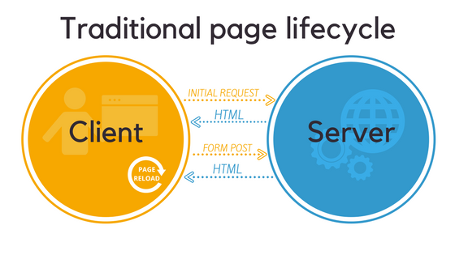



SITE MAP

# Screenshots

# I.Homepage



navbar

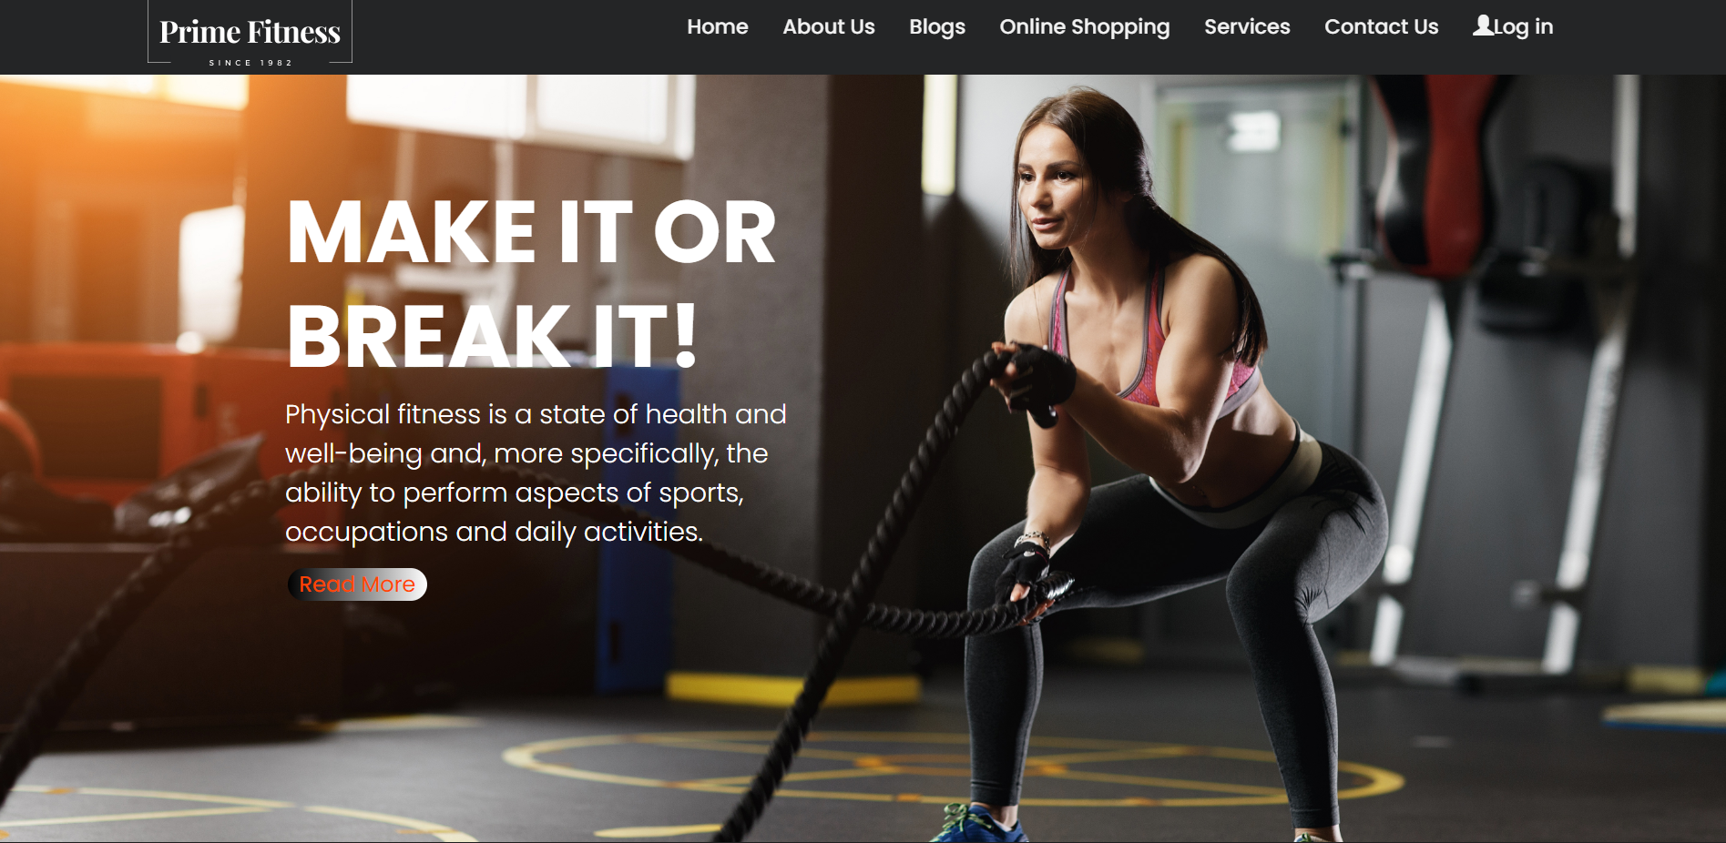

.Banner of shop

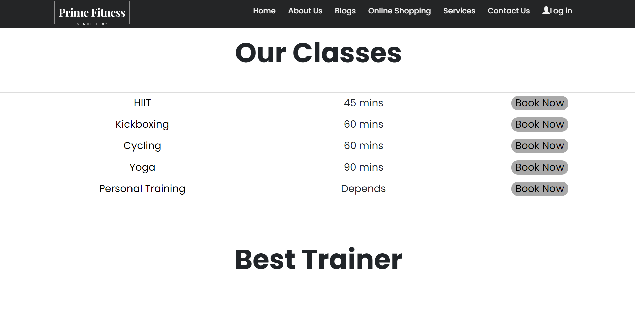

Services

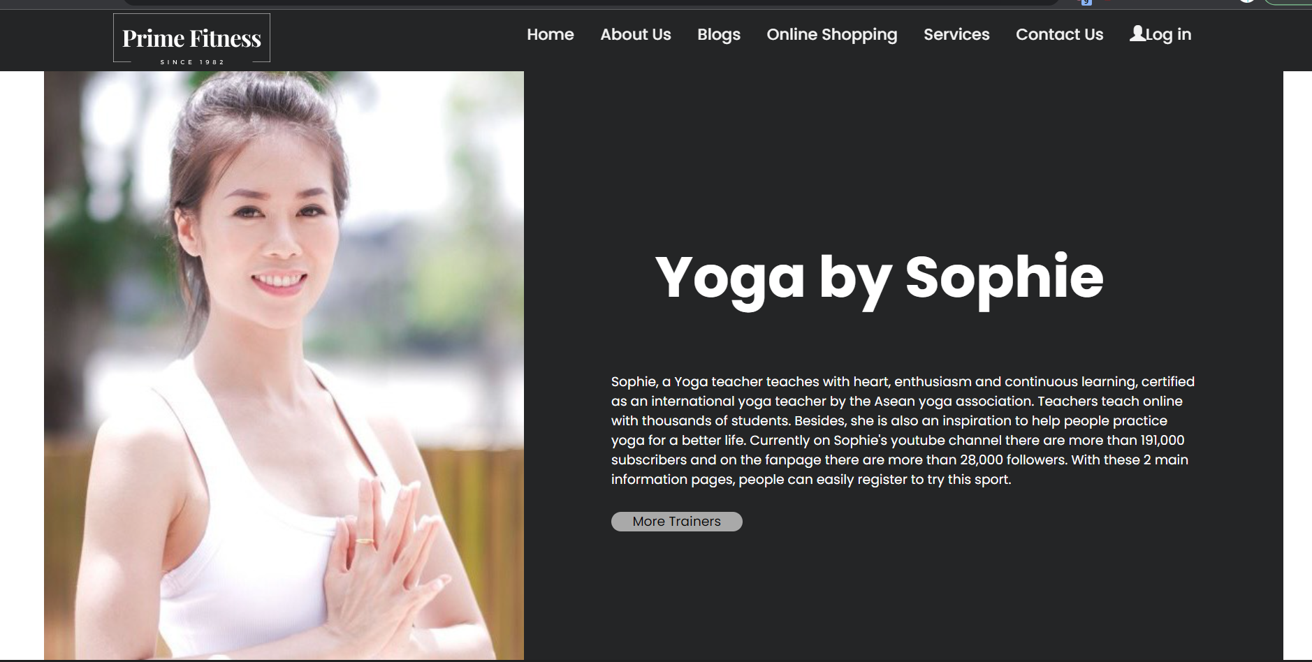

Best Trainer

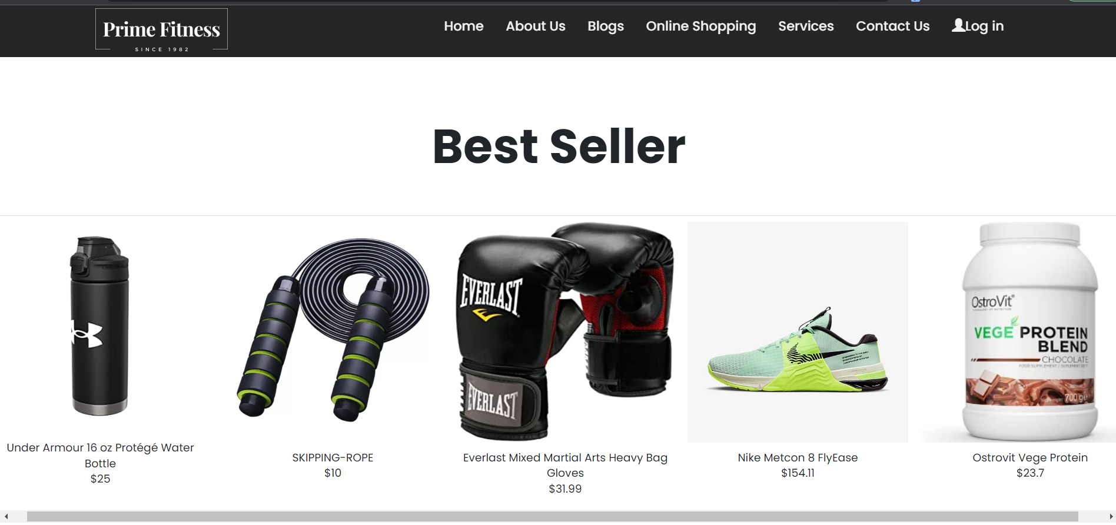

Best Seller

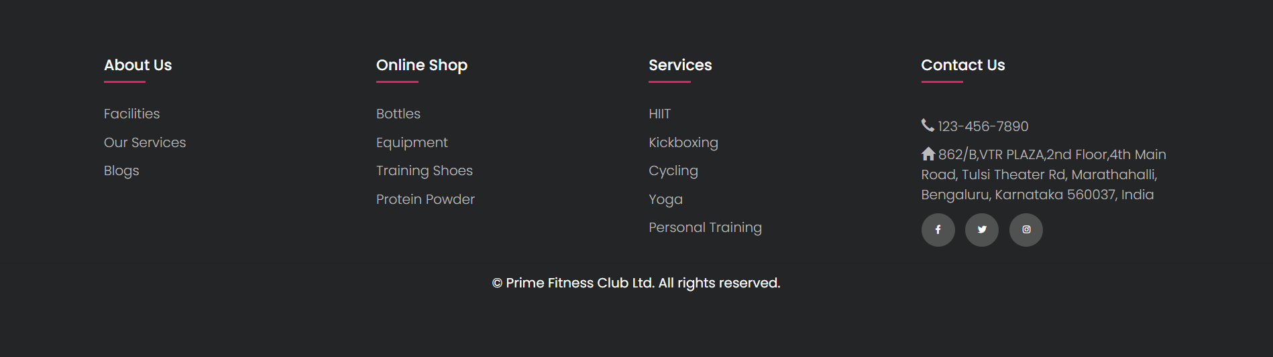

.Footer

# II.Categories

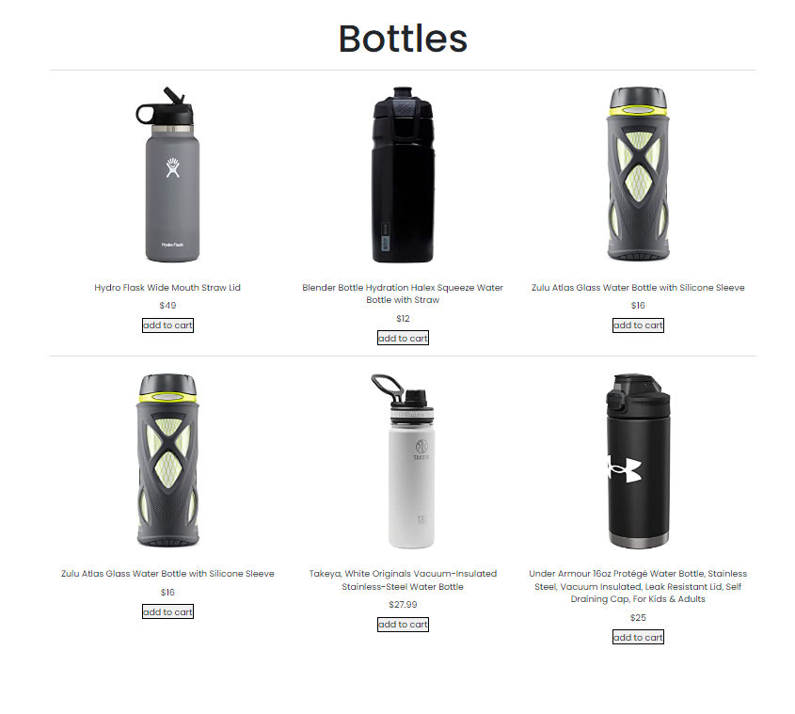

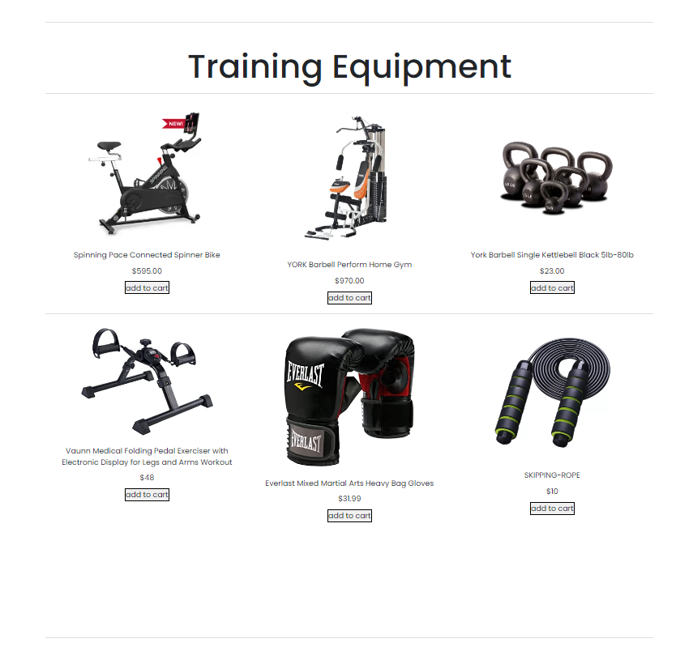

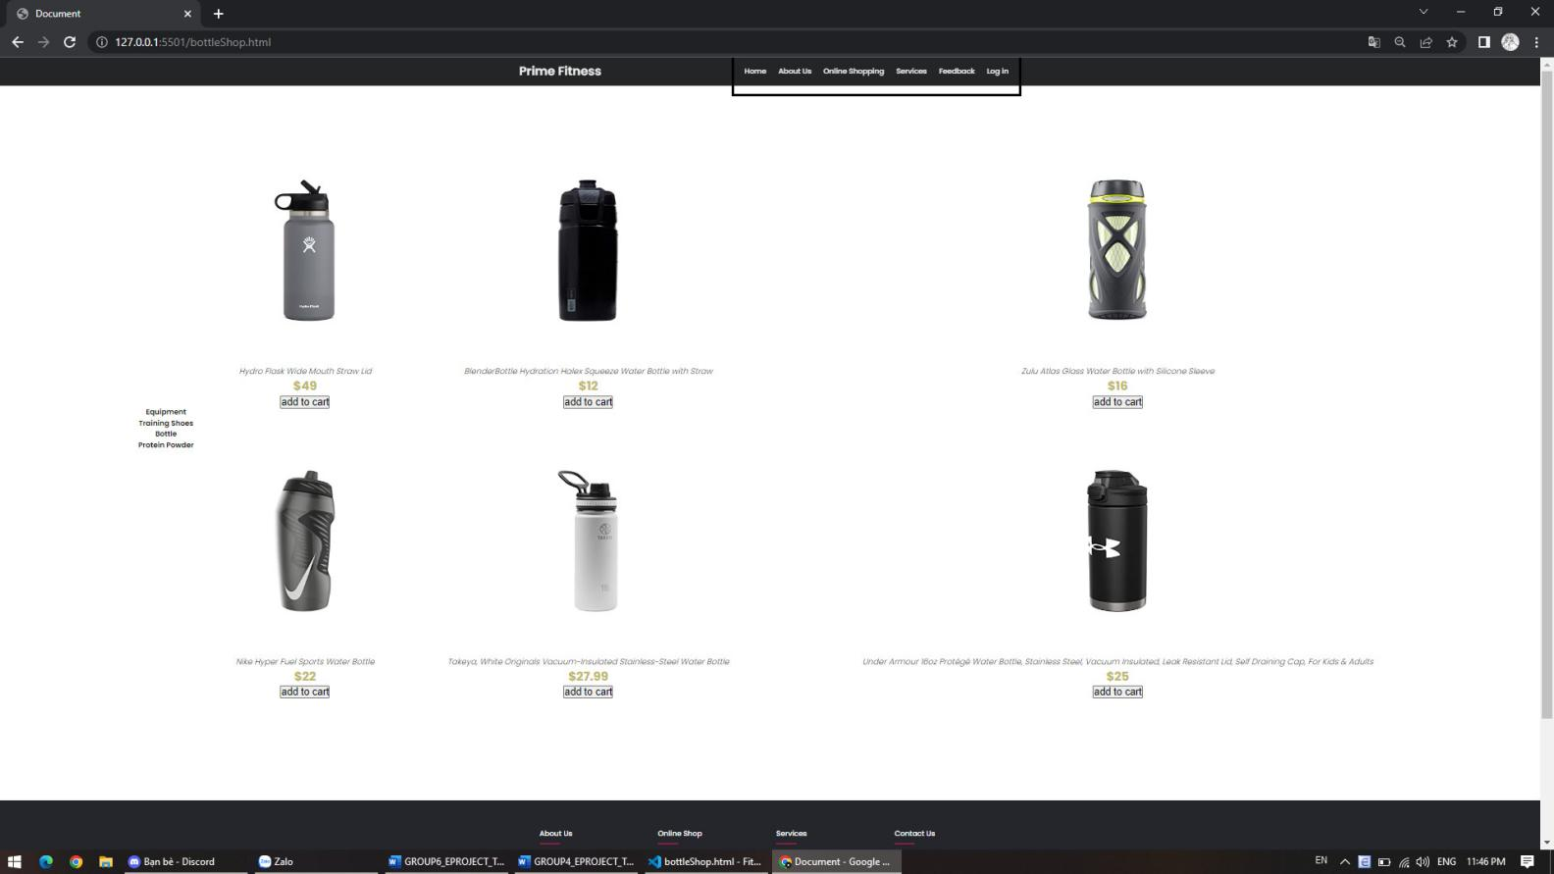

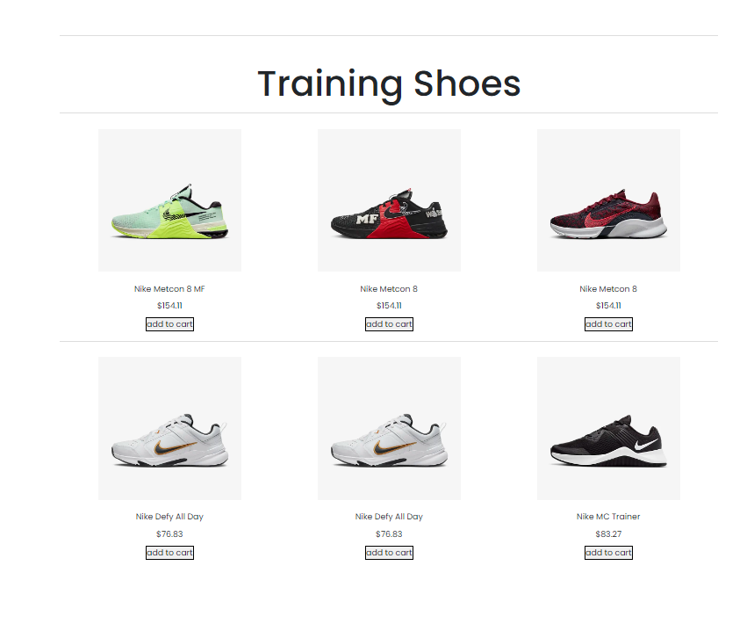

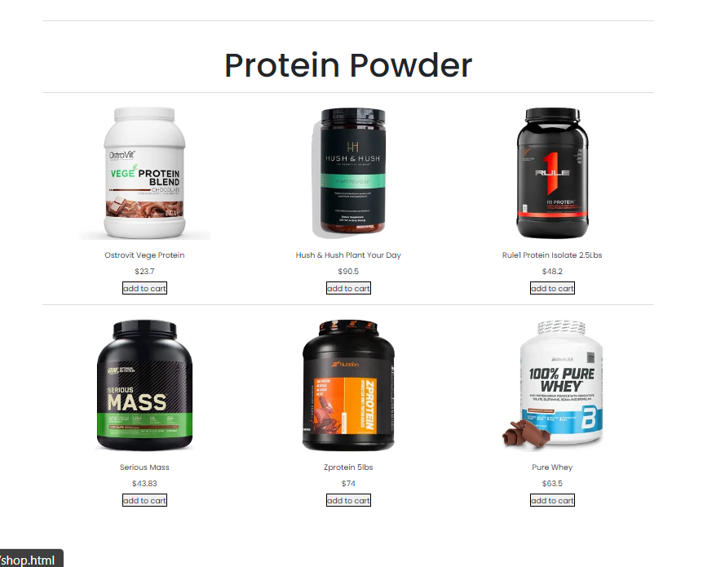

***Some image about Categories page***

.Filter of page

# III.About us:

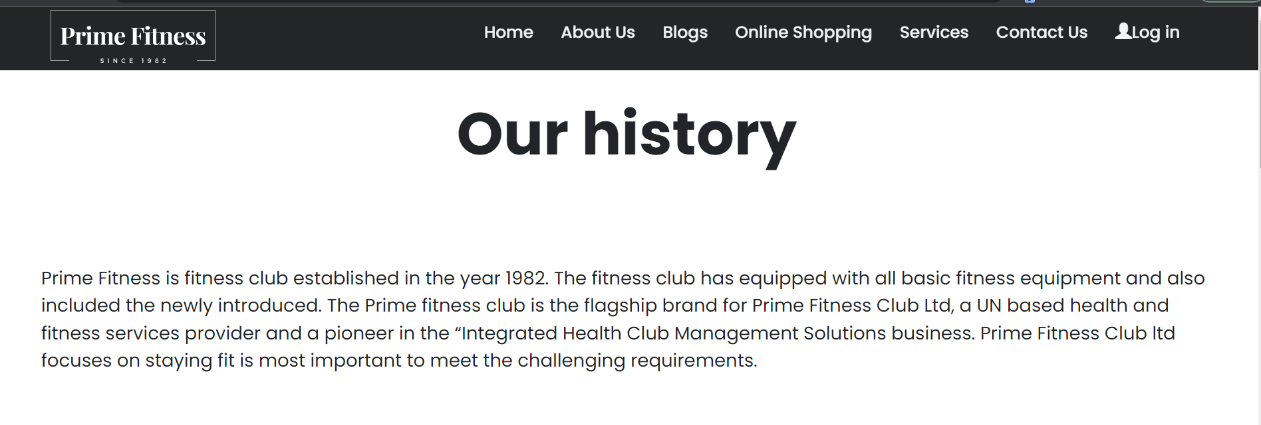

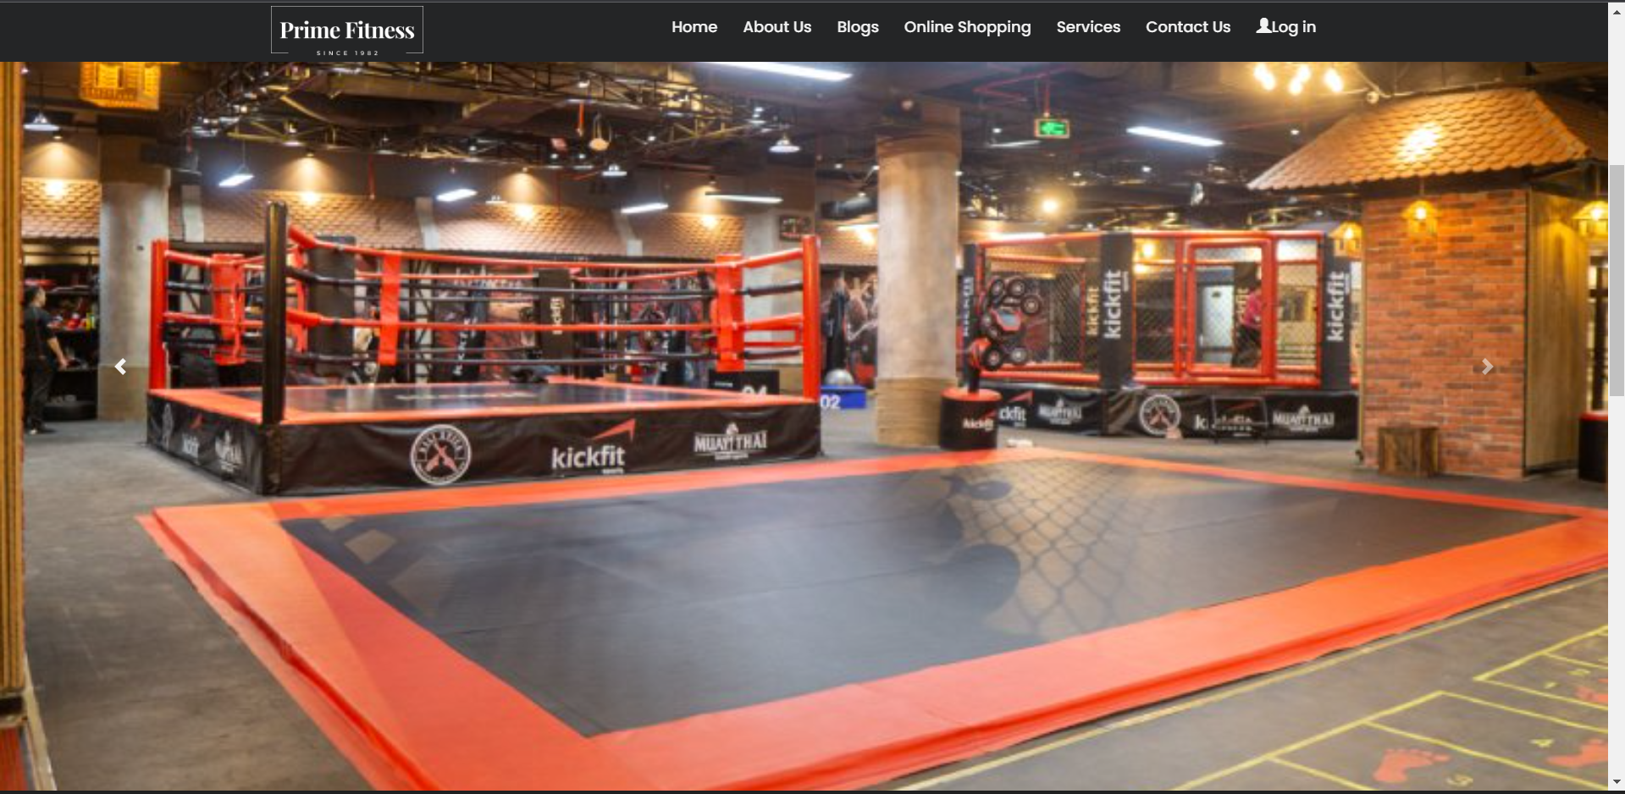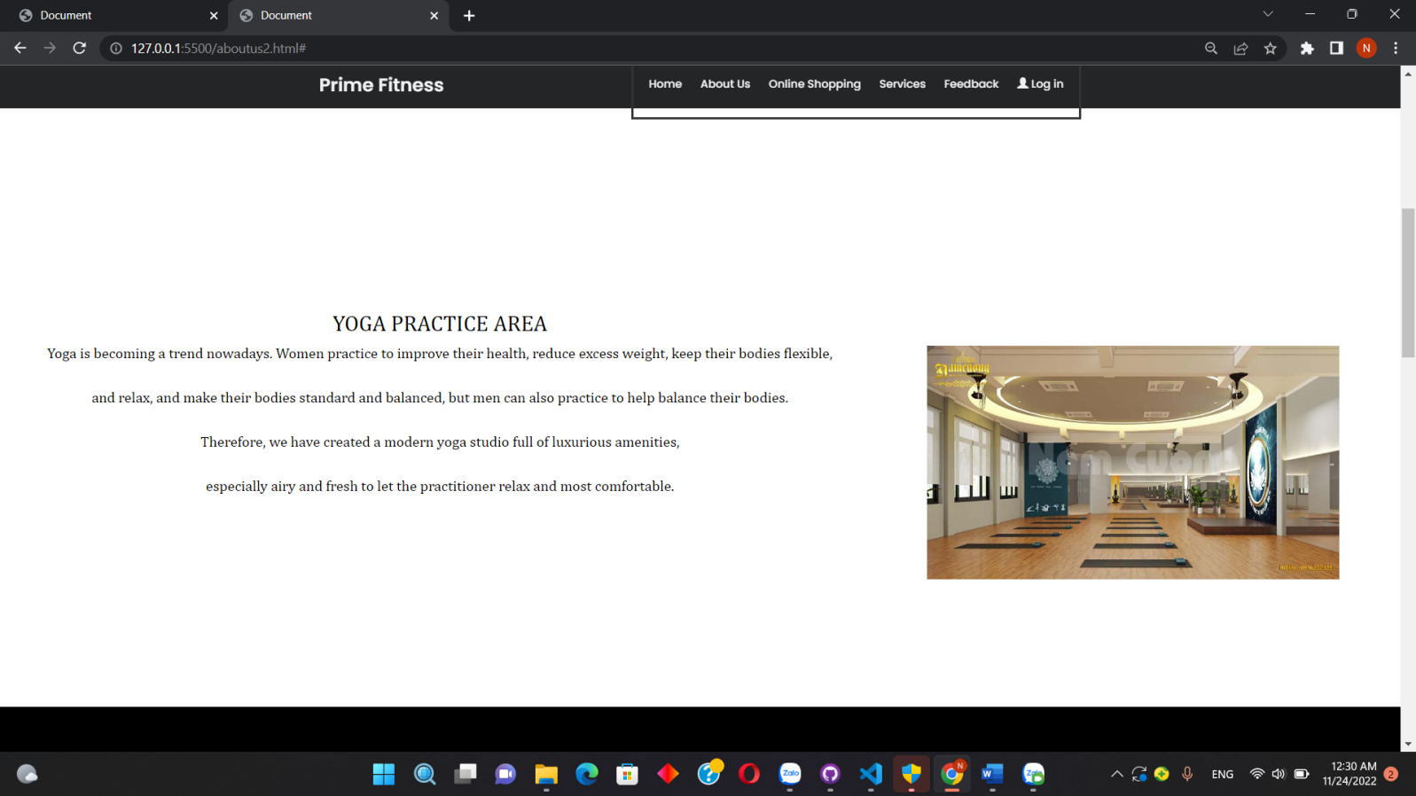

(carousel)

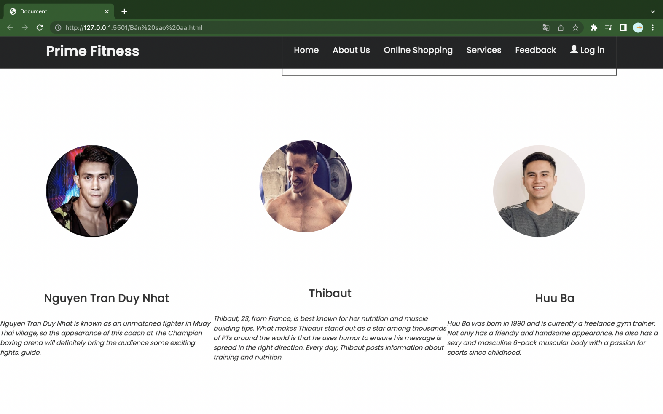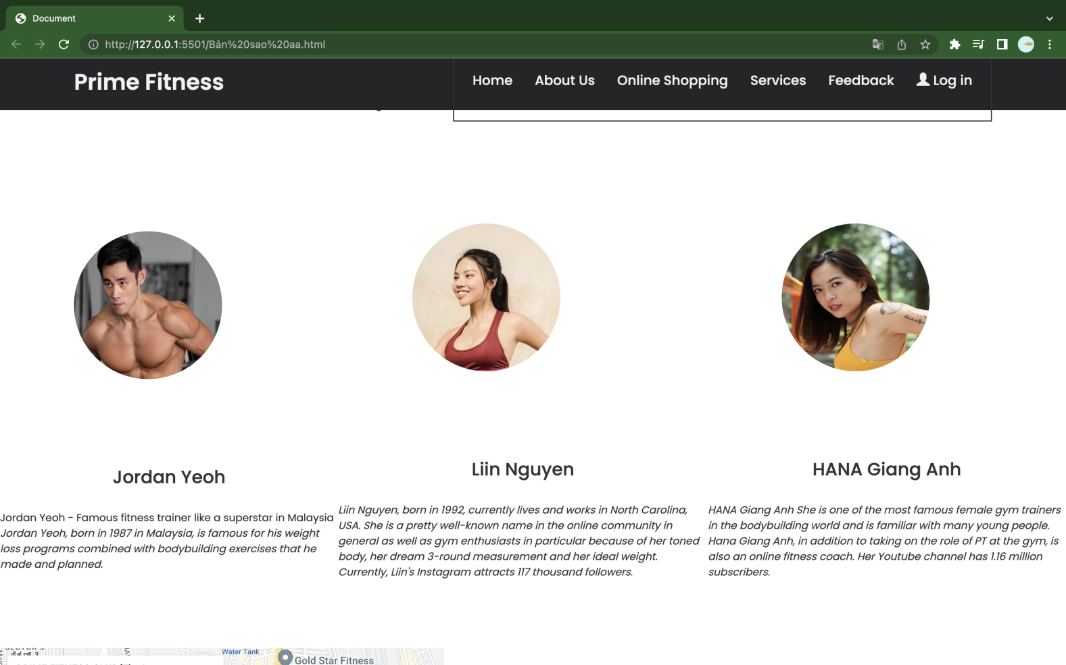

IV. SINGLE PRODUCT

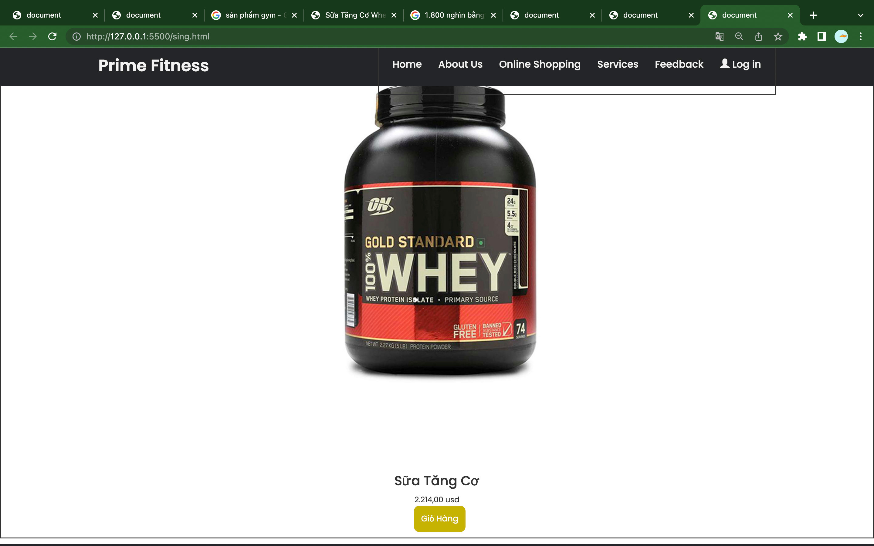

Task sheet

|  |  |  |  |  |  |  |  |
| --- | --- | --- | --- | --- | --- | --- | --- |
| No | Member | Contents | Page Name | Activity Plan | Date of Preparation of Activity Plan | | |
| Planed Start Date | Actual Start Date | Actual End Date | Status |
|  | Hồng Ngọc Nhi | Home page | home.html | 14/11/2022 | 16/11/2022 | 23/11/2022 | 100% |
|  | Contact us | contactUs.html |  | 25/11/2022 | 3/12/2022 | 100% |
|  |  | Shop (layout) | Shop.html |  | 25/11/2022 | 3/12/2022 | 100% |
|  | Phùng Thị Thùy Linh | shop | shop.html | 14/11/2022 | 16/11/2022 | 23/11/2022 | 100% |
|  | Single Product | Shop.html |  |  |  |  |
|  | Nguyễn Trung Nguyên | Trainer info | aboutus.html | 14/11/2022 | 16/11/2022 | 23/11/2022 | 100% |
|  | Single Product | Shop.html |  |  |  |  |
|  | Nguyễn Đức Tú | Equipment info | aboutus.html | 14/11/2022 | 16/11/2022 | 23/11/2022 | 100% |
|  | Single Product | Shop.html |  |  |  |  |
|  | Nguyễn Bảo Trân | blogs | Blog.html |  |  |  |  |